**Registration Page**

The state diagram of registration page verifies all the basic information about the user and then will create an account for that specific user. The registration UI will get all the basic information from the user and then pass them to the register controller. The security system will verify the user basic information. If all the values valid and unique, the new account will be created for that specific user.

The below screenshot shows the State diagram of registration page.

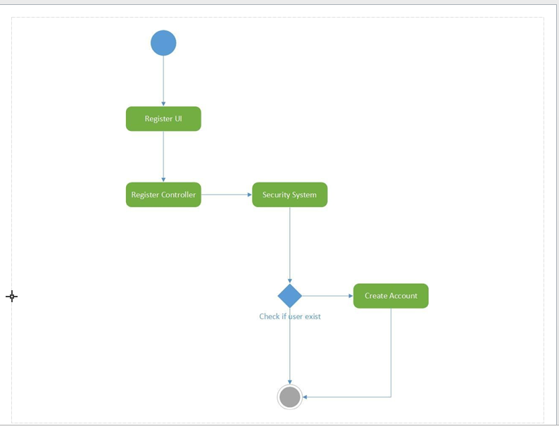

**8.3. Home Page**

The home page displays the blood donor information. Once the user gets the information about the donor, they can logout the home page. The state diagram shows the logout steps clearly in the below screenshot. The request logout passes the request to the logout controller. The logout controller closes the session.

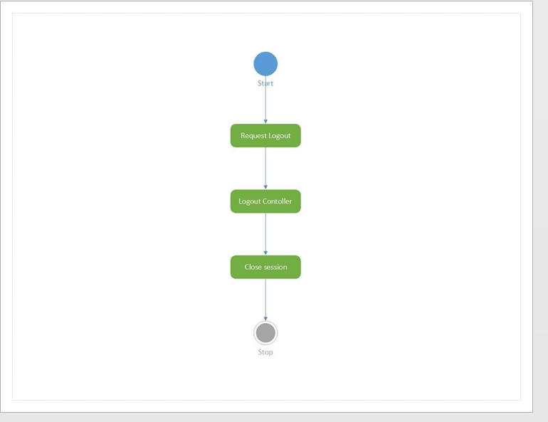

**9.Class diagrams**

**9.1. Login Page**

The login of the class diagram describes the flow of the system and process. The loginUI has the Username and password variables. Those variables are passing to the login controller through the GetCredentials. The system verifies the login credentials by using the authenticate function.

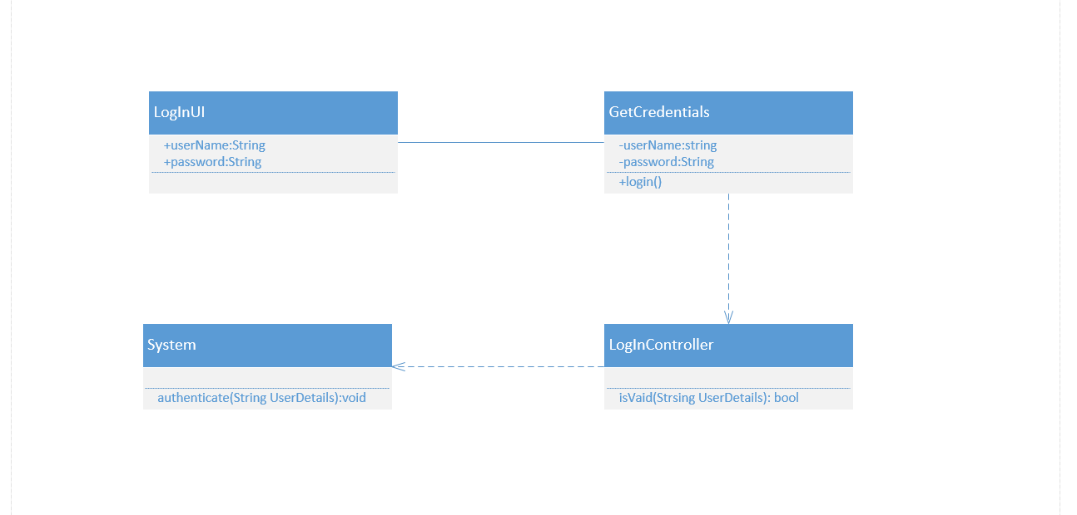

**8.2. Registration Page**

Similar to login page, the registrationUI takes all the necessary variables and pass them to the registration controller. The registration controller verifies the basic details and then the new account creates by the Admin.

The below screenshot shows the class diagram of registration page.

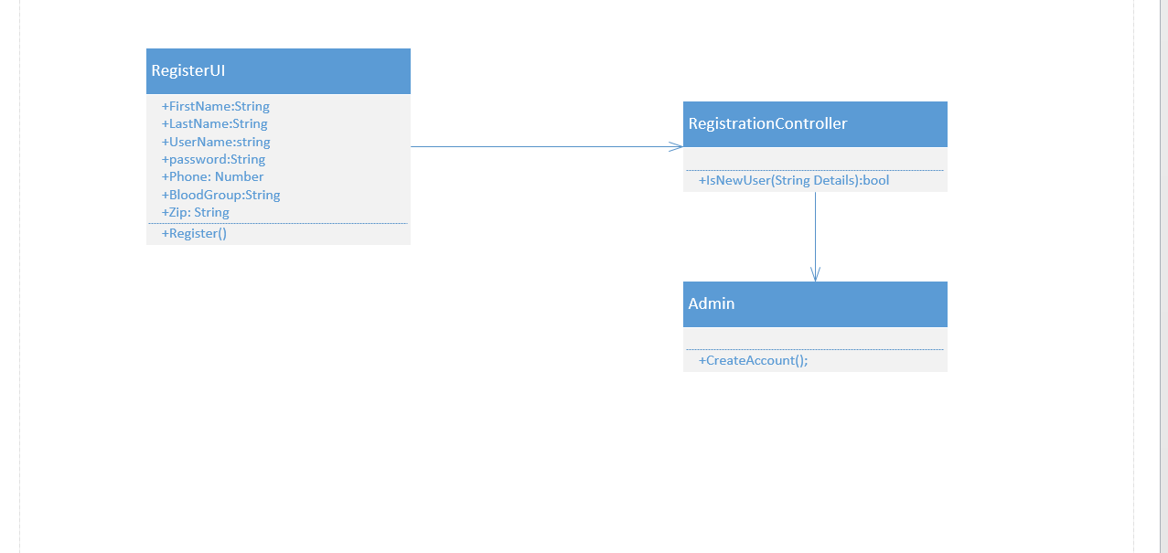

**8.3. Home Page**

The home page donor search will take places by the search variables from the HomeUI. The search operation will happen based on the zip code and the blood type. Finally, the result will be displayed based on the blood type and zip code.

The below screenshot shows the class diagram of home page



**9.Class diagrams**

**9.1. Login Page**

The login of the class diagram describes the flow of the system and process. The loginUI has the Username and password variables. Those variables are passing to the login controller through the GetCredentials. The system verifies the login credentials by using the authenticate function.

